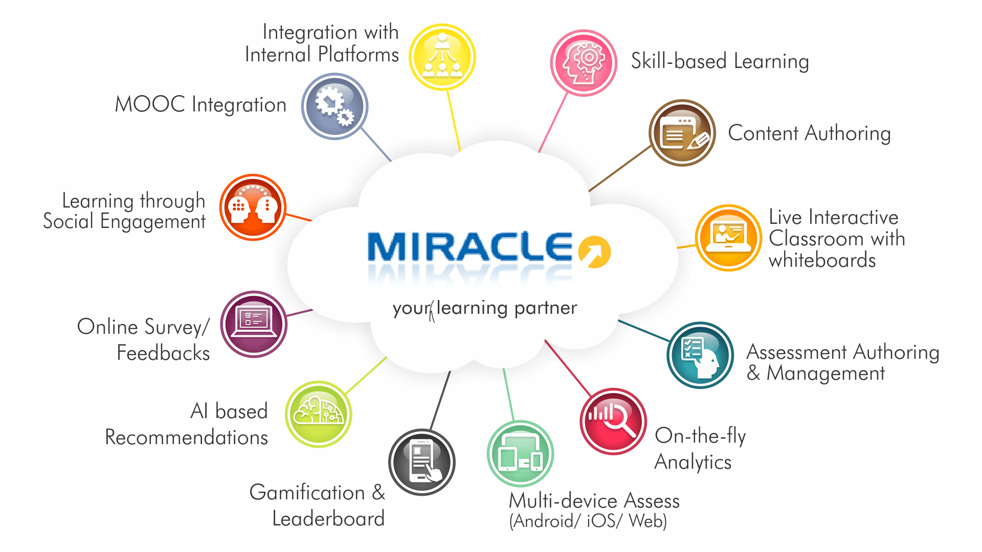

Miracle,93112305846/7 . www.miracleindia.com

Feature Matrix – Miracle LMS
Classroom Training | Comments
Print attendees photos | Print roster with photos of the attendees, so you know the student´s faces and names before entering the classroom
Scheduling Classes/Sessions | You get to schedule your online classes in MLMS
Registration/Cancellation | You, as an LMS admin, can manage the complete registrations and cancellations within the LMS
Wait list | Wait listed students can be auto promoted or manually promoted; includes email notification
Attendance | In the report and tracking area, the Administrator can track attendance status.
Sign-in-sheet printing | The system allows for class rosters, and appraisals from the instructor standpoint related to the performance of a student in a classroom course.
Resource scheduling | You get this as an inbuilt feature in the LMS
Course Material Access | You can upload the following types of training materials: Video, HTML files, slide converter, tests, surveys.

Communication Tools | Comments
Notifications via emails | MLMS allows you to send the email notification to the users regarding course update, upcoming event, webinar, etc.
Notifications inside platform | You get to set triggers according to the requirement
Newsletter | You get to option to enrol into the monthly newsletters
Calender | Calendar allows the admin to set the notification for upcoming events, webinars, courses, quies etc. It will be reflecting on the user profile
Upcoming events | You can get your users to take note of the upcoming events
Course Content |  | Comments
Book - Multi-page resources with a book-like format. Teachers can export their Books as IMS CP (admin must allow teacher role to export IMS) |  | Paradiso LMS allows the admin to add e-book as a part of courses
File - A picture, a pdf document, a spreadsheet, a sound file, a video file |  | Admin gets to add files to easily uploaded to the LMS as part of the course
Folder - For helping organize files and one folder may contain other folders |  | You can have folder option in the course to add the additional material in an organised manner
IMS content package - Add static material from other sources in the standard IMS content package format |  | All the content you have in the IMS content package format can be uploaded to the MLMS
Label |  | Can be a few displayed words or an image used to separate resources and activities in a topic section, or can be a lengthy description or instructions
Page - The student sees a single, scrollable screen that a teacher creates with the robust HTML editor |  | Your users can see a single, scrollable screen HTML page as a part of the course.
URL |  | You can send the student to any place they can reach on their web browser, for example Wikipedia
SCORM 1.2, 2004 |  | MLMS is SCORM 1.2 and 2004 compliant
AICC |  | MLMS is AICC compliant
LTI |  | MLMS is LTI compliant
Youtube |  | You can embed YouTube videos and add interactions to the video
Vimeo |  | You can embed Vimeo videos and add interactions to the video
Upload Videos |  | You can upload MP4 format videos easily to the MLMS
Embed any video or html code |  | You can either upload a video in MP4 format or Embed using a link
Flash files |  | You can upload and embed flash files
Course Interactions |  |  | Comments
Forum |  |  | Both general discussion forum(social wall) and course based forum are available in the MLMS
Chat |  |  | Chat feature is available in the MLMS. Via this feature, the users can interact with each other.
Feedback |  |  | There are feedback and survey tools available in MLMS
Glossary |  |  | Alphabetical list of terms in a particular domain of knowledge with the definitions for those terms
Wiki |  |  | A wiki page is a web page any user in the LMS can create together, right in the browser, without needing to know HTML
Workshop |  |  | Workshop is a peer assessment activity with many options. Your students can submit their work via an on line text tool or attachments.
Social Wall |  |  | Social wall allows post submission interface, timeline of posts, filtering of the timeline and integration with LMS's activities and resources.
Checklist |  |  | Create check list for onboarding or pre-requisites or anything you want
Custom forms |  |  | These give you the ability to create custom forms with custom fields
Knowledge base |  |  | This gives you the ability to create knowledge base with moderation required from admins

Course Creation Process | Comments
Easy to Use course creation Wizard | You get a 3 step course creation wizard with lot of atteractive features
Youtube | You can upload Youtube videos in the LMS in the MP4 format or embed link
Different types of course formats (Tabs, Grid, Social, Topics etc) | MLMS supports different types of course format which also includes (Tab, Grid, Social Topics, Discussion Forums etc.)
Support for Classroom, virtual, elearning and social learning | In MLMS, you get exhaustive support for classroom, virtual, elearning and social learning.
Location base training | You get to set location based training sessions in the MLMS
Bulk Enrolments | You can create Cohorts(Bulk Users) and enroll them to a course or many courses
Blended and Online Learning | You can use a mix of Instructor Led training or live virtual classroom along with online learning
Guest Access | You, as the LMS admin, can allow guest access to the users in the login settings
Competency based course allocation | MLMS gives you the option to allocate courses based on competency
Web Services Support | You can build custom applications by calling MLMS support services
API Documentation | MLMS provides exhaustive REST API documentation and support
Course Authoring | Comments
HTML Pages | Using our editor, you, the LMS admin, can create HTML pages with just a few clicks
Course Presentations | You can create interactive presentations in html5 format (mobile compatible)
Embed iframe | You can put content from external secure sites directly into your course using iframe
Dashboard | Dashboard can be accessed by both managers and users, however the view would be different for a manager and a user
Performance Management | Comments
Learning Plan | Learning path can be easily set by you, the LMS admin. It allows you to set credit points to the course, also the certificate can be allocated at the end of the course
Student Portal | Comments
Student Dashboard | You, the LMS Admin, can set the student dashboard by adding blocks according to your requirement
Custom Welcome message | You, the LMS admin, can set a welcome video or message to show when users login for the very first time
Rotating banner | You, the LMS admin, can set rotating banners showing latest courses or important messages to students
Customizable landing page | You, the LMS admin, can configure where the student´s landing page- my courses or course catalogue or social wall or whatever page within the site
Private files | Your students/users can upload files which only they will have access to
Support | Comments
Phone | In case you have suggestions / feedback, you can call in to discuss it with the assigned account manager
Email | In case you have suggestions / feedback, you can email them to your assigned account manager
Tickets | In case you have suggestions / feedback, there is a provision to raise tickets
Chat | You can chat directly and voice your feedback/suggestions/grievances
Documentation | You can refer to the documentation available and resolve your queries.
System Administration | Comments
Custom Roles and Permissions | If you are the super admin, you can set roles and grant permissions to manage the system, each role has certain permissions
Certificate | There are prebuilt certificates available in the LMS, and can be customized according to your requirement
Automatic Enrolments | You, the LMS admin, can enable the auto enrolment option while creating courses
Wait list management | You, as the LMS admin get to create a waitlist in case the maximum amount of course participants is reached. They later get enrolled automatically as soon as free seats are available
User Interface | Comments
Company branding | The MLMS is completely customizable. You can change the logo, colour theme, background, login page image etc
Login page background | You, as the LMS admin, can put rotating images or static image and enable or disable social login from admin panel
Custom Theme | The LMS theme can be changed and managed as per your requirement, also it is possible to create a custom theme under theme settings in MLMS
Prebuild templates | There are prebuilt templates in MLMS that you can utilize to set modules on the home page
Remove Paradiso link from footer or login page | It is possible to remove the Paradiso links from the footer or login page, also we provide complete white-labelled LMS
Gmail Calendar Sync | Gmail calendar can be synchronized with the MLMS, the events automatically gets uploaded onto the calendar
Outlook Calendar Sync | Outlook can be synchronized with the MLMS, the events automatically gets uploaded onto the calendar
Multi-language support | MLMS supports multiple languages
Home page | You, as the LMS admin, has ability to configure customized home page for students or admins , for ex. admin can set the home of students to my courses or course catalog or a particular course or social wall
User Management | Comments
Bulk Upload | MLMS allows you, the LMS admin, to upload bulk users in Excel format
Customized Profile | MLMS allows the admin to create custom profiles for users.
Social Login | It gives you, the LMS admin and the users the ability to login into LMS using Google+, Linkedin, Facebook, Twitter, Office 365 and many other social platforms
Self Registration with or without approval | You, as the LMS adming can set the self registration as an option. Once user self registers, they receive their login credentials
Custom roles | You can set custom roles in the system
Secure Messaging/Inbox | In the user profile, LMS allows to admin/manager to send a secure message to the user
My team view | You can see admin/manager in my team view in the dashboard
Enrollment approvals | Within dashboard, you, as the LMS admin/manager, can see the enroll approval list
Quiz | Comments
Question bank | MLMS allows you, the LMS admin, to create, preview and edit questions in a database of question categories.
Proctering | MLMS gives the option of browser lock down and other tools to prevent cheating
Reports | MLMS generated detailed reports on different aspects of quiz completion including individual questions
Feedback | MLMS gives you the ability to provide feedback after each question or at the end of the quiz

